Traffic simulation

Design document



**Table of content**

**Introduction** **3**

**Functionality** **3**

**UML diagram** **3**

**Sequence diagrams** **4**

Simulation Constructor 4

Simulation.Start() Method 4

Simulation.addLife() Method 5

Life moveTo() Method 5

**Projected work division** **6**

# Introduction

The objective of the simulation is to present real traffic situations in a dynamic model. It will aim for analyzing traffic flows, plan public transport services, test impacts of one way streets, using input and output parameters such as: flow, speed, travel time, queue length, intersection type, turning direction.

# Functionality

Once the application is started the user will be able to create the desired road map by selecting the tiles on the map editor. Once the map is created the user has to input a number of cars for simulation and run the application; additionally user can select if events will be included such as closing a selected road or adding an ambulance. The simulation will end once all the cars are in the ending position which will be predefined. User can view in real time statistics provided by the simulation and can save them once the simulation is done.

# UML diagram

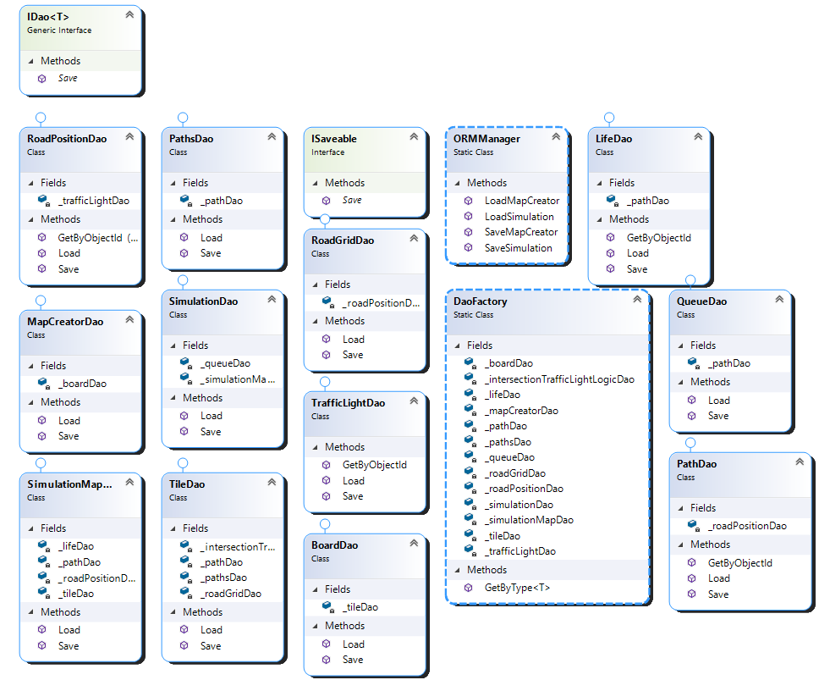

# Sequence diagrams

## Simulation Constructor

## Simulation.Start() Method

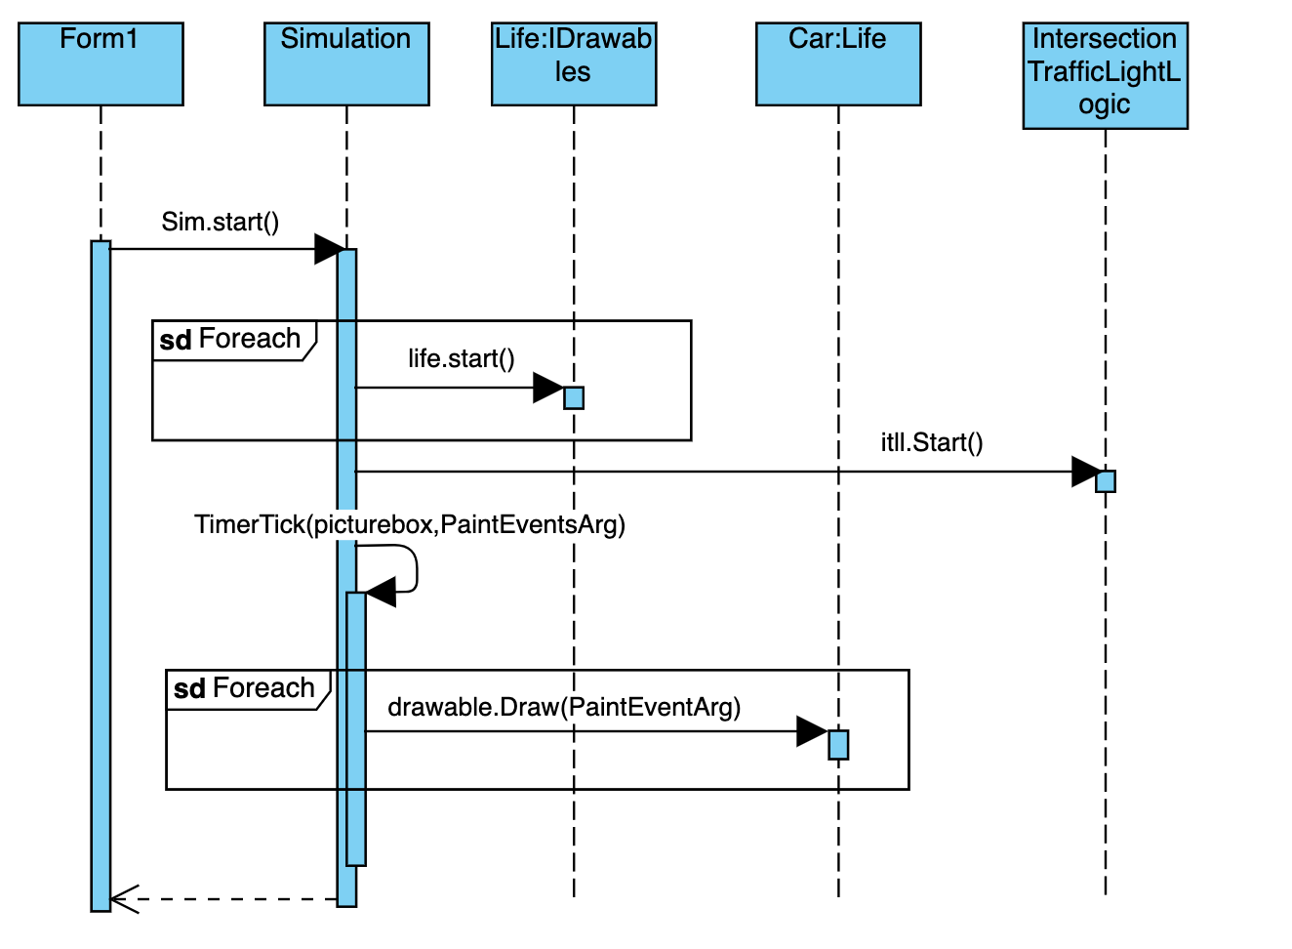

## Simulation.addLife() Method

## Life moveTo() Method

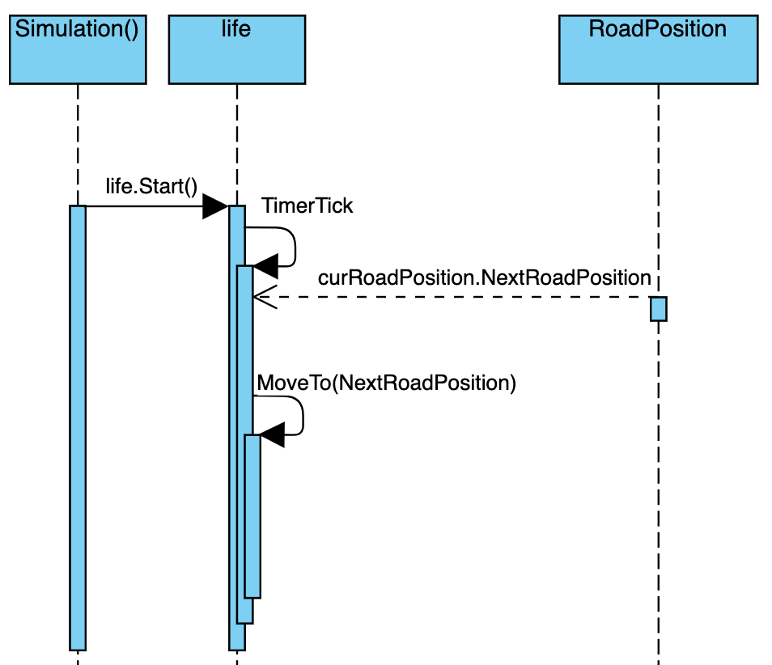

# Projected work division

1. Load and Save Map :: Vincent de Moll / Maya Barakova (M.I.A), Marcello Cardillo

* Check if the tile fits with the next one (end of road to start of road)
* Spawn points in maps
* Implementation of single / multiple lanes
* Dynamically create RoadPosition Matrix
* Implement road position to lists in matrix
* Unit Tests

1. Statistics :: Mihail Lepadatu / Marcello Cardillo / Kaylee Joy Furst

* Easy / Live Stats:
  + Total number of cars processed.
  + Time taken for a car to complete the route (total for live).
  + Current Amount of cars stopped.
  + Current amount of cars driving.
  + Total Distance travelled by cars
  + Time simulation has been running
* Smart Stats / Data interpretation
  + Road usage over time (Heat map)
  + Average Road Usage
  + Bottlenecks
  + Inflow & Outflow
* Save statistics to a specified location ( .txt , JSon , XML )

1. Random Events :: Kaylee Joy Furst / Jasper Vos

* Choose one random event ( closing road / ambulance )
* Adjust traffic flow correspondingly
* Adjust traffic lights